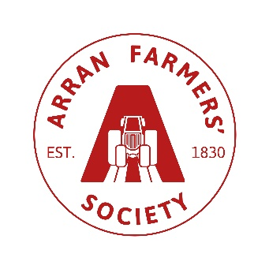
Additional Information Required: (Must be completed)

No. of Pens requested- Cattle
***Cattle Declaration - must be signed***
I declare that my holding has a "negative" herd status for BVD virus
Holding No:-
Signed:-

No. of Pens requested – Sheep
(min. of 3 per pen, per section)

BF/Leicester – Sheep
BF/Leicester -
Sheep MV & Scrapie Qualifying

Other breeds – Sheep

Other breeds –
Sheep MV & Scrapie Qualifying

Stockhandlers:-
Name: Address:

Transportation:-
Name & Address of Haulier/ borrowed trailer, or self if own transport & box

